**Group 3: practice 4**

Nguyễn Huy Hoàng – 20194433

Trần Quốc Khánh – 20190085

Hoàng Thiện Tâm – 20194450

Phạm Như Thuấn - 20194456

* We set up the 3 nodes cluster:

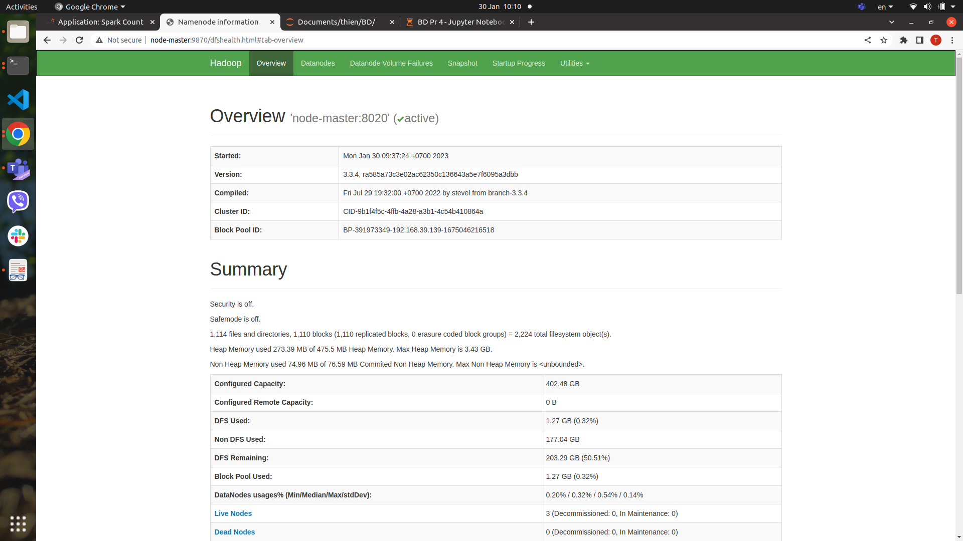

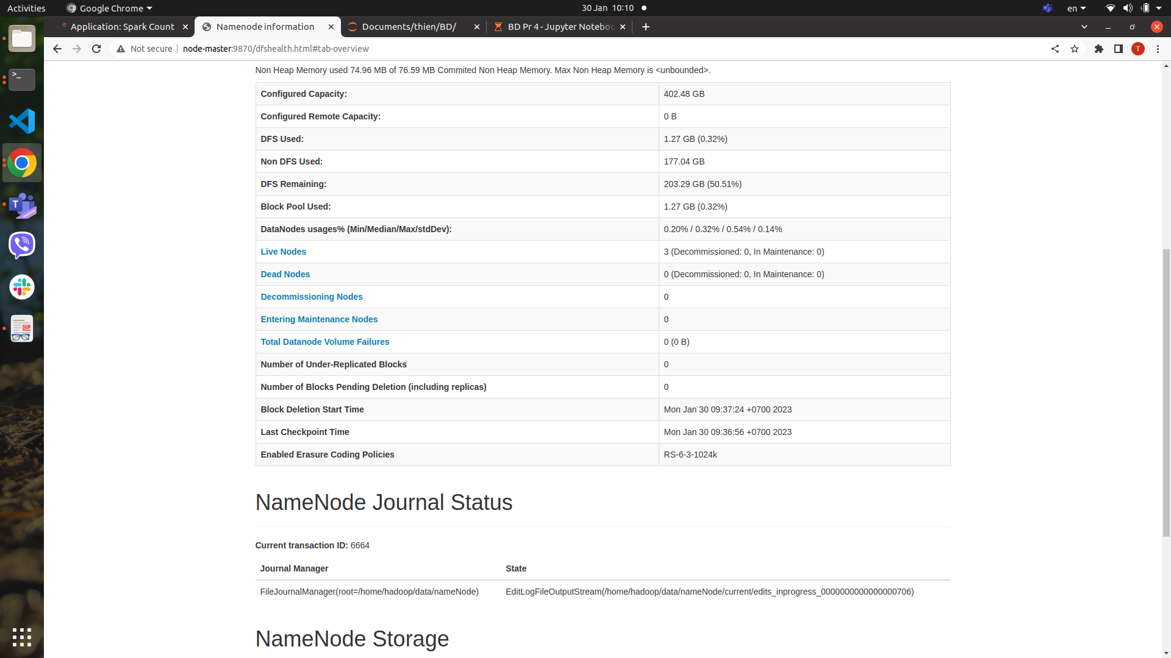

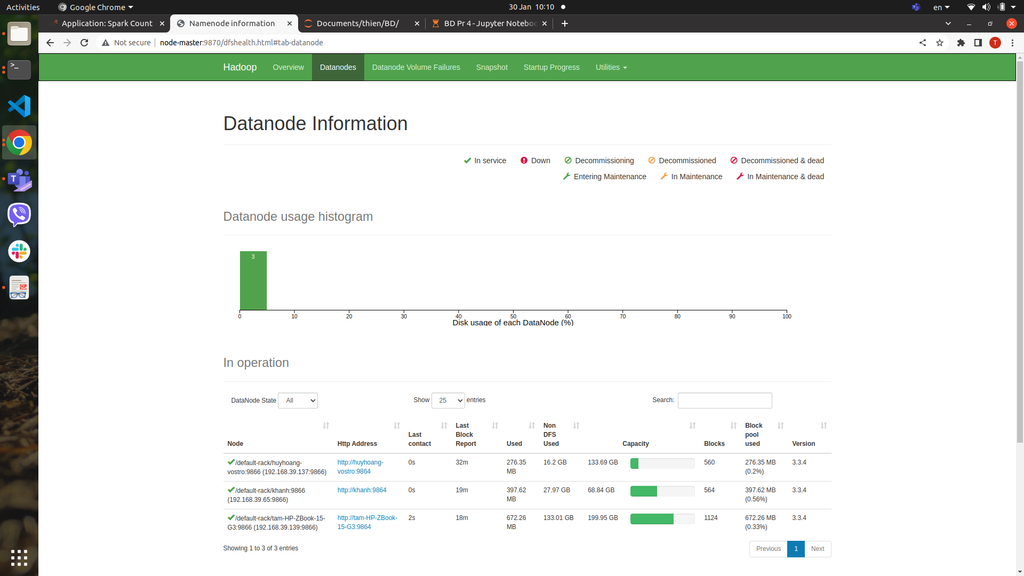

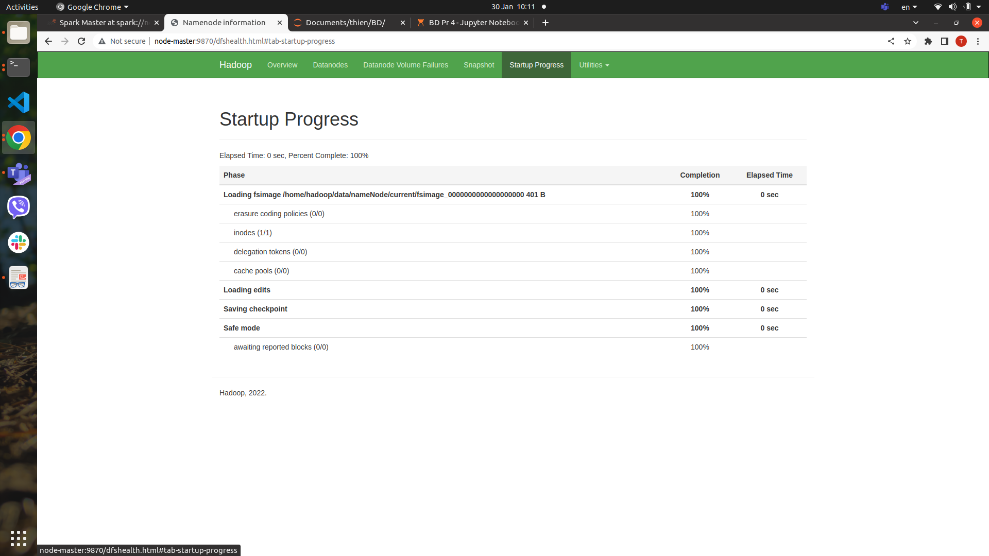

* Put 1 Gb data

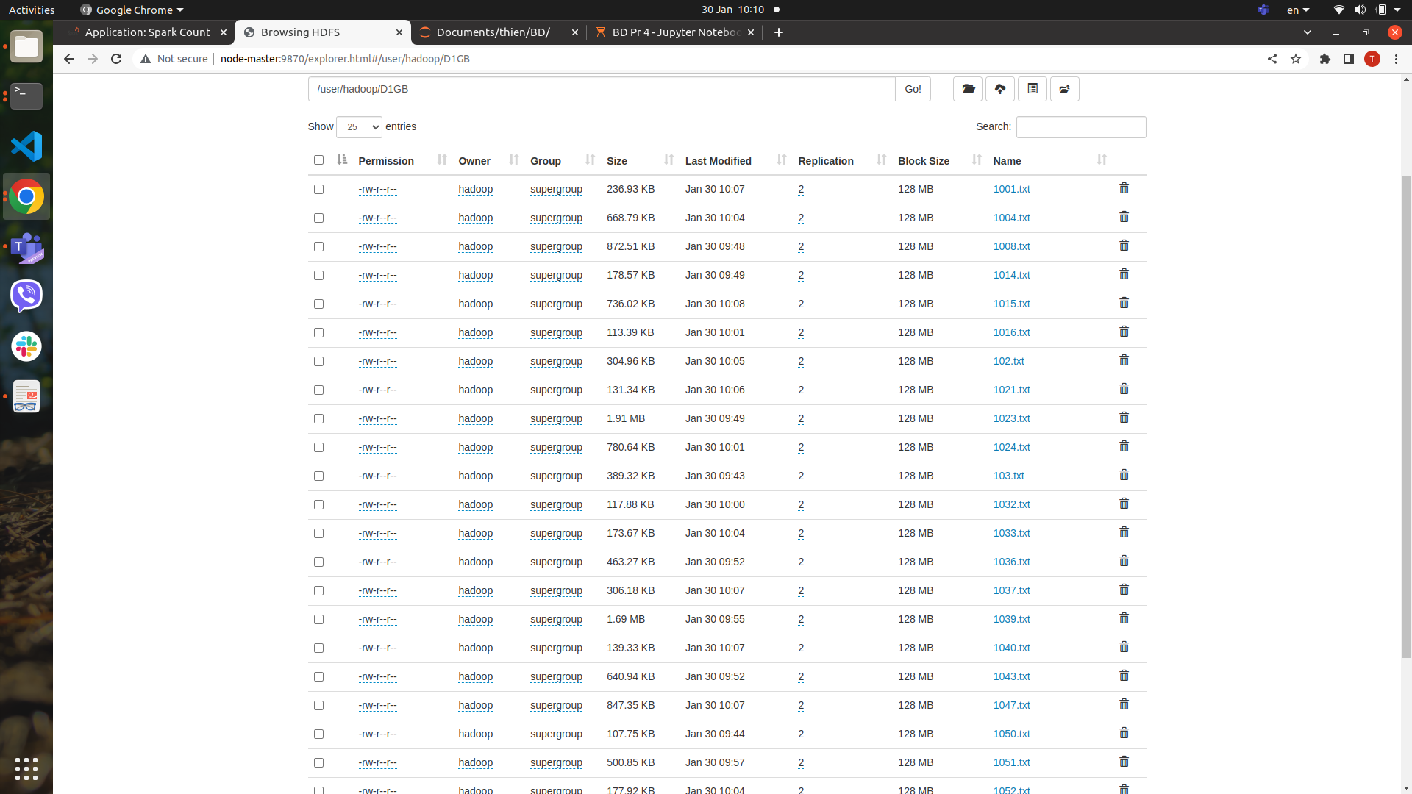

* Specify the url to access the data in hdfs

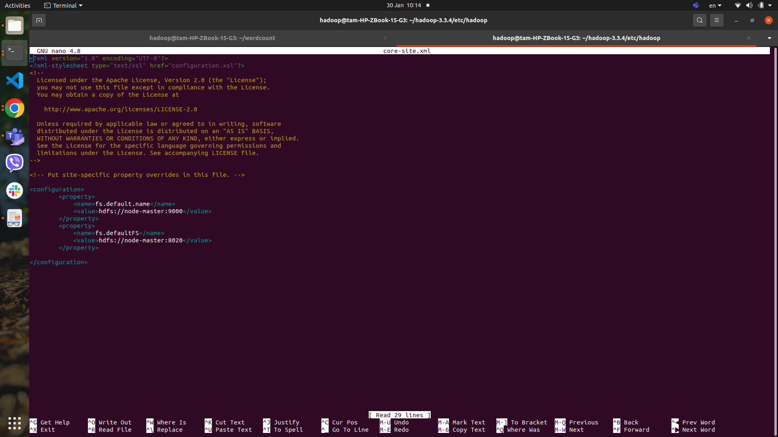

* Application on spark api

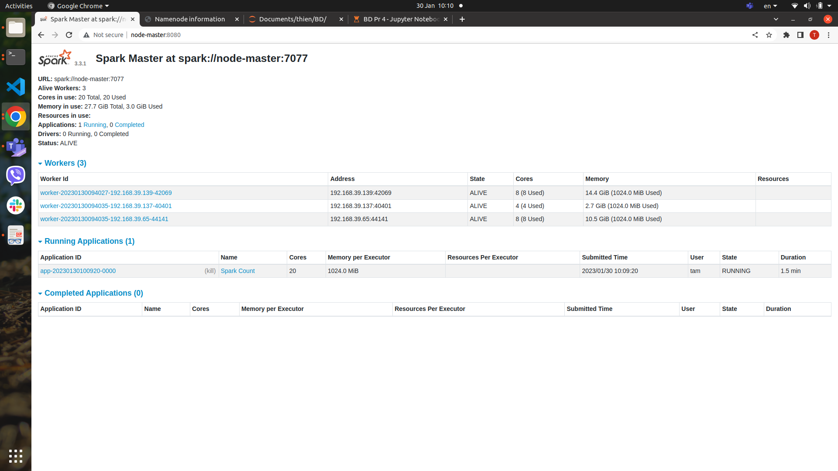

* Job detail of the application Wordcount

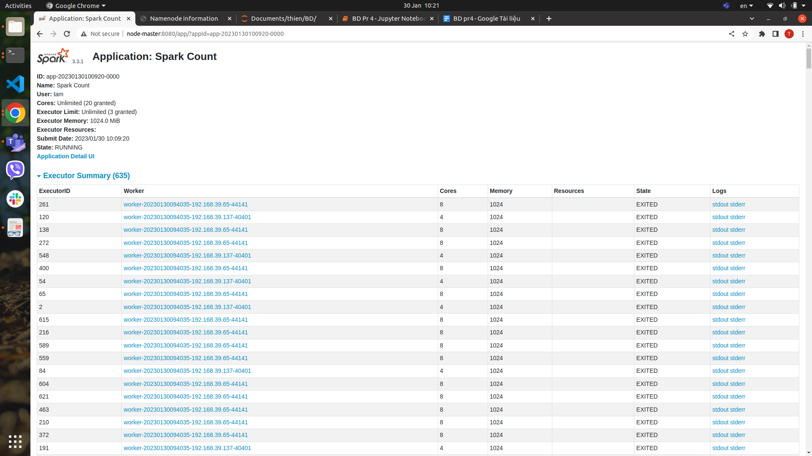

* Jupyter code and result

